Project Synopsis
StructLens: Revolutionizing Structural Health Assessment Through AI Innovation
1. Problem Statement & Existing Landscape
The Status Quo: Current Structural Health Monitoring (SHM) solutions rely heavily on basic Computer Vision (CNNs). Existing tools (like v7labs) can identify that a crack exists and draw a bounding box around it.
The Gap: These systems fail to answer the critical engineering questions:
- "What did this look like before?" (Lack of baseline for comparison).
- "Why did this happen?" (Lack of causal reasoning—e.g., distinguishing Shear vs. Flexural stress).
- "How do we fix it?" (Lack of actionable repair intelligence).
- Civil engineers do not just need a "label"; they need a diagnosis and a treatment plan.
2. Proposed Solution
RetroSpec is an end-to-end forensic AI pipeline that goes beyond detection. It introduces "Visual Time-Reversal"—the ability to computationally reconstruct the pristine state of a damaged structure. By comparing the Current (Damaged) state with the Generated (Healthy) state, the system isolates the defect with pixel-perfect precision and uses a Multimodal LLM to generate a professional engineering report compliant with safety codes (e.g., ACI/IS codes).
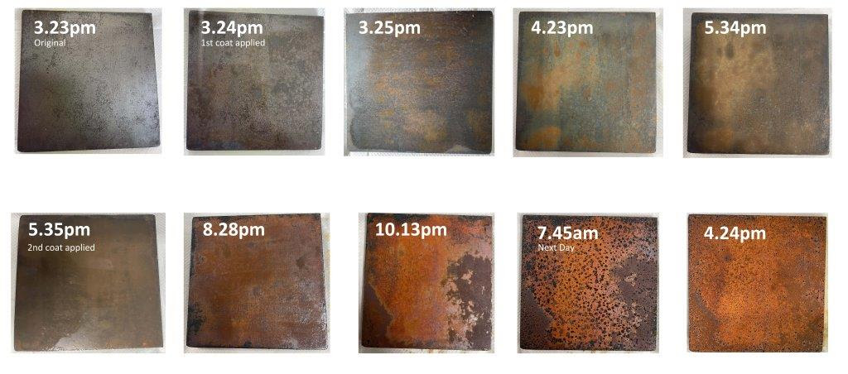

3. Methodology (The 3-Stage Pipeline)
The system operates on a unique "Detect-Restore-Diagnose" architecture:
- The Eye (Quantification): A fine-tuned Segmentation Model (U-Net/YOLOv8) scans the uploaded image to identify defects (cracks, spalling, corrosion) and extracts geometric data (width, length, orientation).
- The Time-Machine (Restoration): A Generative Diffusion Model (e.g., Stable Diffusion Inpainting) removes the defect and synthesizes the texture of the healthy material, creating a "Virtual Baseline" ().
- The Engineer (Reasoning): A Multimodal LLM (RAG-based) analyzes the visual data alongside the geometric metrics. It references civil engineering standards (IS 456 / ACI 318) to determine the root cause (e.g., "Diagonal crack due to shear failure") and prescribes the correct repair method.
4. Key Innovations (Why this is unique)
Feature | Existing Systems | RetroSpec (Your Project)
Output | "Crack Detected" (Bounding Box) | "Shear Failure: Repair with Epoxy Injection"
Visuals | Overlays Red Lines | Generates "Restored" Clean Image
Analysis | Binary (Damaged / Safe) | Causal (Why it broke)
Utility | Data Collection Tool | Automated Consultant

5. Expected Outcomes
- Automated Metrics: Precise calculation of crack width and area by subtracting the Restored Image from the Damaged Image.
- Visual Proof: A "Before vs. After" visualization that helps stakeholders understand the severity of the damage.
- Actionable Reports: A generated PDF report that serves as a preliminary audit, reducing the time engineers spend on manual report writing by 70-80%.
6. Technologies Used
- AI Models: YOLOv8 (Detection), Stable Diffusion (Inpainting), Gemini/GPT-4o (Reasoning).
- Backend: Python (Fast API/Flask).
- Frontend: React (for the "Engineer's Dashboard").
- Dataset: SDNET2018 (Concrete Cracks), Mendeley Concrete Crack Dataset.

